**VISVESVARAYA TECHNOLOGICAL UNIVERSITY**

"Jnana Sangama", Belagavi - 590018



A Report on

**AICTE ACTIVITY**

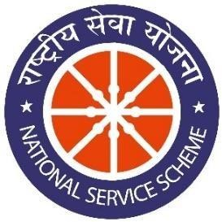

**NON CREDIT MANDATORY COURSE**

Submitted in partial fulfillment of the requirement for the award of the degree of

**Bachelor of Engineering in**

**Computer Science and Engineering**

**By**

**Aditi Das**

**1AY21CS014**

Under the guidance of

**Mrs. BHAVYASHREE S P**

**Assistant Professor**

**Department of Computer Science and Engineering**



**DEPARTMENT OF COMPUTER SCIENCE AND ENGINEERING**

**ACHARYA INSTITUTE OF TECHNOLOGY**

(Affiliated to Visvesvaraya Technological University, Belagavi) 2023-2024

# ACHARYA INSTITUTE OF TECHNOLOGY

Acharya Dr. Sarvepalli Radhakrishnan Road, Soladevanahalli, Bengaluru – 560107

(Affiliated to Visvesvaraya Technological University, Belagavi)

**DEPARTMENT OF COMPUTER SCIENCE AND ENGINEERING**



## CERTIFICATE

Certified that the report entitled **AICTE ACTIVITY – Usage of 100 percent digitised money in Abbigere, Bangalore** activity carried out by **Aditi Das (1AY21CS014)** in partial fulfillment for the award of degree of **Bachelor of Engineering in Computer Science and Engineering of Visvesvaraya Technological University**, **Belagavi** during **6th semester** in the year **2023-2024.** It is certified that all corrections/suggestions indicated for internal assessments have been incorporated in the report deposited in the departmental library. The activity report has been approved as it satisfies the academic requirements in respect of project prescribed for the **Bachelor of Engineering Degree**.

|  |  |  |
| --- | --- | --- |
| Signature of AICTE Coordinator | Signature of HOD | Signature of Principal |
| **Mrs Bhavyashree S P** | **Dr. Ajith Padyana** | **Dr. Rajath Hegde. M.M** |
| **Assistant Professor** | **HOD** | **Principal** |

**AICTE Officer, AIT**

**External**

**Name of Examiner Signature with Date**

1.

2.

## DECLARATION

I , student of 6th semester, B.E Computer Science and Engineering, Acharya Institute of

Technology, Bangalore, hereby declare that the activity report entitled **“AICTE Activity – Usage of 100 percent digitised money”** in Abbigere, Bangaloreis an authentic activity report of my own work carried out under the supervision and guidance of Mrs Bhavyashree S P, Assistant Professor and Aicte CSE Department Coordinator, Department of Computer Science and Engineering, Acharya Institute of Technology, Bangalore. I have not submitted the matter embodied to any other University or Institution for the award of any other degree.

Date:

Place: Bengaluru

**Aditi Das 1AY21CS014**

## ACKNOWLEDGEMENT

We express our gratitude to our institution and management for providing us with good infrastructure, laboratory, facilities and inspiring staff, and whose gratitude was of immense help in completion of this report successfully.

We are deeply indebted to **Dr. Rajeswari** Principal, Acharya Institute of Technology, Bengaluru, who has been a constant source of enthusiastic inspiration to steer us forward.

We heartily thank **Dr. Ajith Padyana**, Head of the Department, Department of Computer Science and Engineering, Acharya Institute of Technology, Bengaluru, for his valuable support and for rendering us resources for this activity.

We specially thank **Mrs. Bhavyashree S P,** Assistant Professor and AICTE Department Coordinator, Department of Computer Science and Engineering, Acharya Institute of Technology, Bangalore who guided us with valuable suggestions in completing this project at every stage.

We would like to express our sincere thanks and heartfelt gratitude to Computer Science and Engineering staff members, our beloved Parents, Respected Professors, Classmates, Friends and non-teaching staff for their indispensable help at all times.

Last but not the least our respectful thanks to the Almighty.

**Aditi Das 1AY21CS014**

### INTRODUCTION

In the modern era, digital money has emerged as a revolutionary alternative to physical currency, transforming the way we conduct financial transactions. As technology continues to advance, the adoption of digital money has become increasingly prevalent, driven by the need for more efficient, secure, and hygienic payment methods. Digital money encompasses a variety of forms, including cryptocurrencies, mobile wallets, and online banking systems, all of which offer unique benefits and features that cater to the diverse needs of users worldwide.

The shift towards digitized money offers numerous advantages, including enhanced convenience, improved security, and reduced risk of disease transmission through contaminated physical currency. Digital transactions are typically faster and more efficient than traditional cash exchanges, allowing for instant transfers and payments that can be conducted from anywhere in the world. This increased convenience is especially beneficial in our fast-paced society, where time is a valuable resource.

Furthermore, digital money offers improved security measures, such as encryption, two-factor authentication, and biometric verification, which help protect users' financial information from fraud and theft. The ability to track and trace transactions also adds an additional layer of security, ensuring transparency and accountability in financial dealings. This feature is particularly important in combating money laundering and other illicit activities.

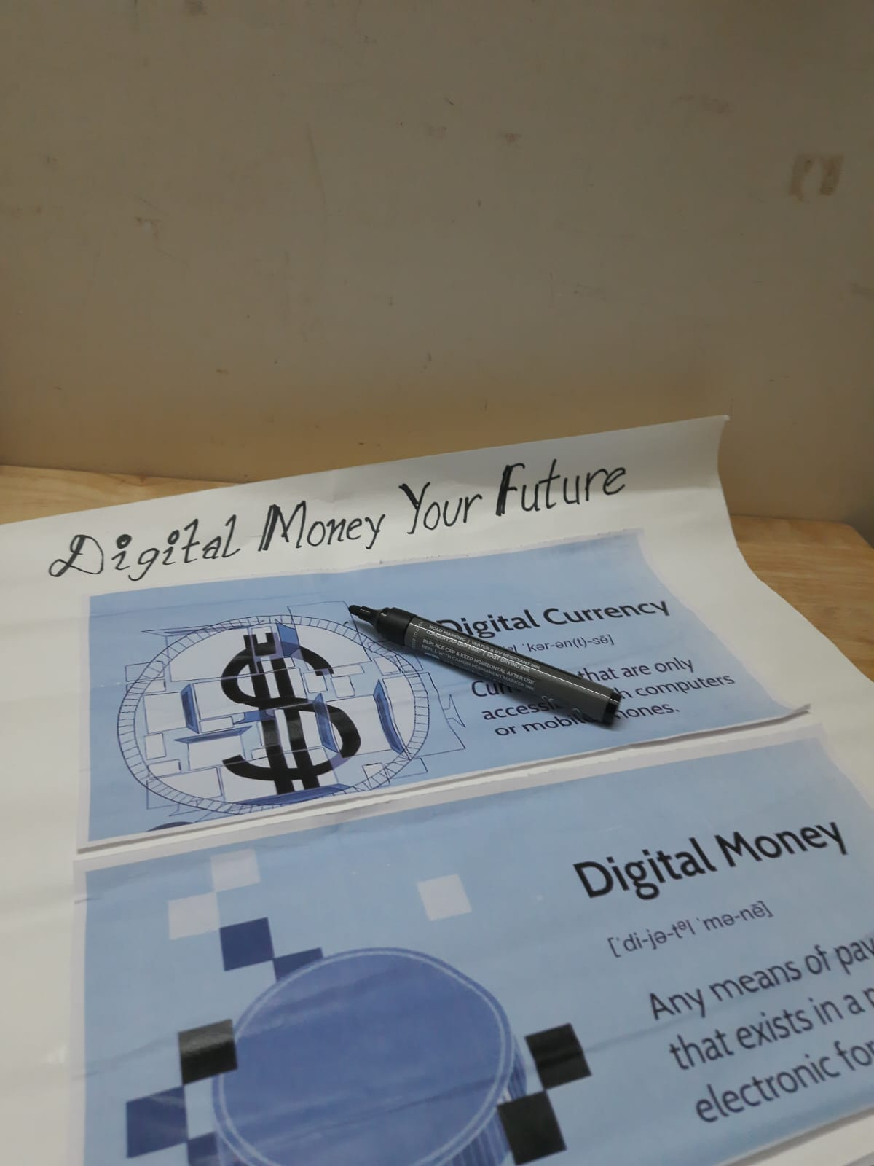

**THE RISE OF DIGITIZED MONEY: TRANSFORMING FINANCIAL TRANSACTIONS**

**OBJECTIVE:**

The primary objective of this initiative is to raise awareness about the benefits of digital money and encourage its widespread adoption. By educating the public on the ease of creating and managing digital accounts, we aim to foster a greater understanding of the security and convenience digital currency offers. Moreover, promoting the use of digital money can significantly reduce the spread of diseases associated with handling physical cash, thereby contributing to public health and safety. This report also seeks to outline the structure and execution of an educational activity designed to achieve these objectives through team collaboration and creativity.

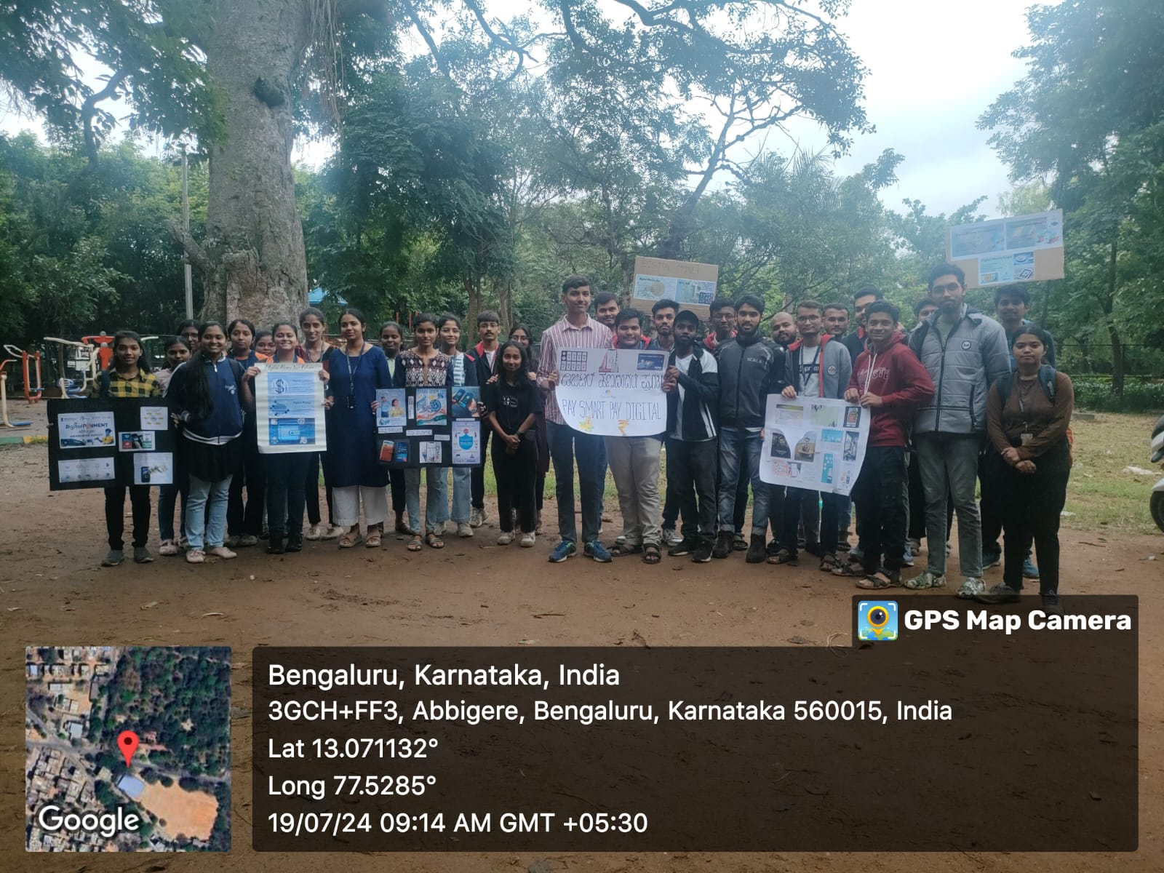

**PARTICIPATION:**

Participation in this initiative involves team collaboration, where each team is tasked with creating a poster using a kilogram of cardboard to convey the advantages and practical aspects of digital money. Teams will research various aspects of digital currency, including its benefits, methods of creating and managing digital accounts, and the importance of transitioning from physical to digital money. Participants will engage in brainstorming sessions, design discussions, and poster creation activities, ensuring that the information presented is accurate, comprehensive, and visually appealing. This collaborative effort will not only enhance the participants' understanding of digital money but also their teamwork and creative skills.

**ACTIVITY CONDUCTION**

The activity was conducted in several phases to ensure a systematic and effective approach:

1. **Research Phase**:
   * **Information Gathering**: Teams will start by gathering comprehensive information on digital money. This includes understanding the various forms of digital money, such as cryptocurrencies, mobile wallets, and online banking systems.
   * **Focus Areas**: The research will focus on several key areas:
     + **Benefits**: Identifying the advantages of digital money, such as convenience, speed, and the ability to make transactions without physical presence.
     + **Security Features**: Understanding the security measures in place, such as encryption, two-factor authentication, and the ability to track transactions.
     + **Account Creation and Access**: Learning the steps involved in creating and managing digital accounts, including setting up mobile wallets, using online banking services, and securing accounts.
   * **Sources**: Teams will use various sources, including academic papers, financial websites, expert interviews, and online tutorials, to gather reliable and up-to-date information.
2. **Brainstorming and Planning Phase**:
   * **Team Discussions**: Teams will convene to discuss their findings and brainstorm ideas for the poster. This involves selecting the most important and relevant information to include.
   * **Design Planning**: Teams will plan the layout of their posters, deciding how to organize the content to make it clear and engaging. This includes:
     + **Visual Hierarchy**: Planning the placement of titles, headings, and key points to guide the viewer’s eye through the poster.
     + **Visual Elements**: Deciding on the use of visuals, such as graphs, charts, and images, to support the text and make the information more digestible.
   * **Role Assignment**: Assigning roles within the team to ensure efficient use of time and resources. For example, one person may be responsible for designing visuals, while another focuses on writing the text.
3. **Creation Phase**:
   * **Poster Construction**: Using the provided cardboard, teams will begin constructing their posters. This includes cutting, pasting, and arranging various elements according to the planned layout.
   * **Incorporation of Visuals and Text**: Teams will incorporate visuals, such as infographics and images, along with the textual information. This involves:
     + **Infographics**: Creating infographics that visually represent data and information about digital money, making complex concepts easier to understand.
     + **Textual Information**: Writing clear, concise, and engaging text that explains the benefits, security features, and processes associated with digital money.
   * **Quality Check**: Reviewing the poster to ensure all information is accurate, clear, and free of errors. Teams will also ensure that the visual elements are well-integrated and enhance the overall message.
4. **Display and Presentation Phase**:
   * **Public Display**: The completed posters will be displayed in a public setting, such as a community center, school hall, or public library. This will allow a wide audience to view the posters and learn about digital money.
   * **Presentations**: Participants will present their work to the audience, explaining the key points of their posters. This involves:
     + **Engagement**: Actively engaging with the audience, encouraging them to ask questions and providing detailed explanations.
     + **Demonstrations**: Providing demonstrations, if possible, on how to create and access digital accounts, showcasing the process in real-time.
   * **Audience Interaction**: Participants will interact with the audience, addressing any questions or concerns they may have about digital money. This provides an opportunity to further educate and clarify any misunderstandings.
   * **Feedback Collection**: Gathering feedback from the audience to understand their perceptions and any additional information they may need. This feedback can be used to improve future educational activities and materials.

By following these phases, the activity aims to provide a comprehensive and engaging educational experience, helping to promote the understanding and adoption of digital money in the community.

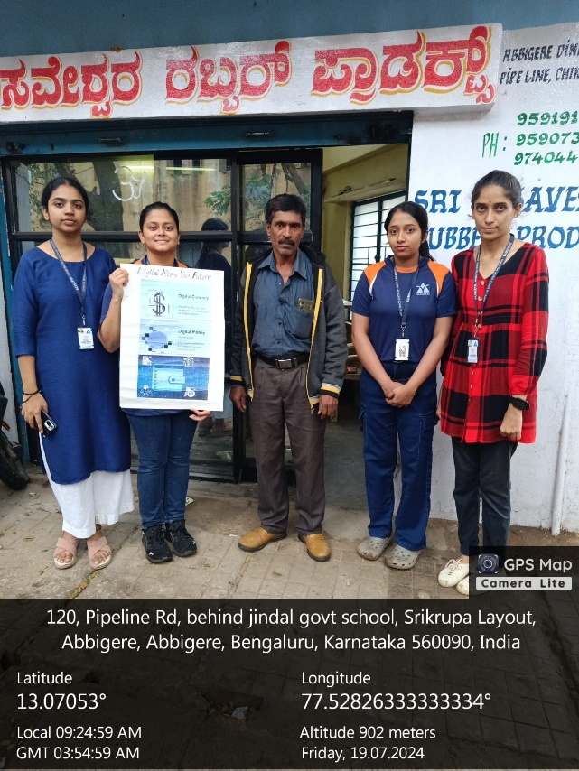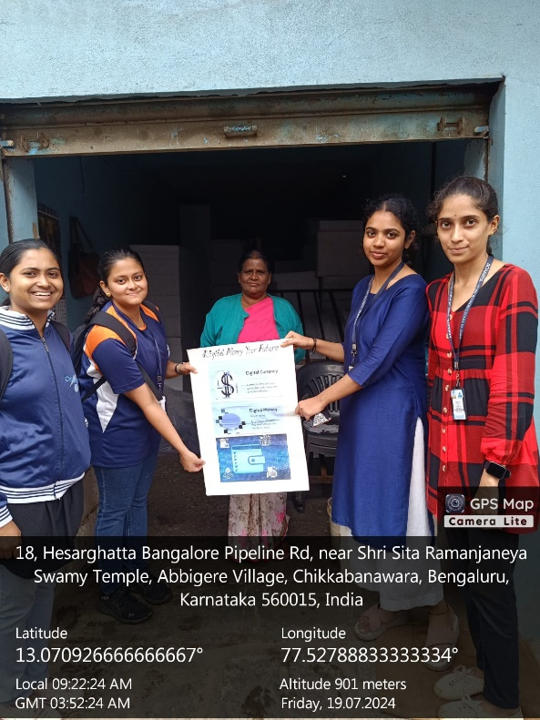

**CHALLENGES :**

Several challenges may arise during the execution of this activity, each requiring careful consideration and strategic planning to address effectively:

**Language Translation Barrier**

1. **Ensuring Accessibility**:
   * **Diverse Audience**: The target audience may include individuals from various linguistic backgrounds. Ensuring that the information on the posters is accessible to everyone, regardless of their native language, is crucial.
   * **Translation Quality**: Accurate translation is vital to maintain the integrity of the information. Poor translations can lead to misunderstandings and misinterpretations, which may reduce the effectiveness of the message.
2. **Translation Implementation**:
   * **Multilingual Teams**: Forming teams that include members fluent in different languages can help ensure accurate translations. These team members can translate the content and verify its accuracy.
   * **Professional Translators**: If team members are not fluent in the necessary languages, hiring professional translators or using reliable translation services can ensure high-quality translations.
   * **Cultural Sensitivity**: Beyond language, cultural nuances must be considered. Certain terms or concepts may not translate directly and might require adaptation to be understood correctly by different cultural groups.
   * **Testing and Feedback**: Testing the translated content with native speakers before finalizing the posters can help identify any issues or misunderstandings. Feedback from these individuals can be used to refine the translations.

**Finding the Right Target Audience**

1. **Identifying the Audience**:
   * **Demographic Analysis**: Conducting a demographic analysis of the community can help identify groups who would benefit most from learning about digital money. Factors to consider include age, income level, technological proficiency, and current usage of digital financial services.
   * **Needs Assessment**: Understanding the specific needs and concerns of different demographic groups can help tailor the message effectively. For example, younger audiences may be more interested in mobile payment apps, while older individuals might need reassurance about security and ease of use.
2. **Reaching the Audience**:
   * **Targeted Communication Channels**: Different demographic groups may have preferences for certain communication channels. Younger audiences might be more reachable through social media, while older audiences might respond better to community meetings or printed materials.
3. **Tailoring the Message**:
   * **Customizing Content**: Tailoring the message to resonate with different demographics involves addressing their specific concerns and interests. For example, highlighting the convenience and speed of digital transactions might appeal to busy professionals, while emphasizing security features and ease of use could reassure older individuals.
   * **Use of Visual Aids**: Using visuals, such as infographics and step-by-step guides, can make the information more accessible and engaging. Visual aids can help bridge language gaps and make complex information easier to understand.
   * **Interactive Elements**: Incorporating interactive elements, such as demonstrations or Q&A sessions, can help engage the audience and provide practical understanding. These elements allow for real-time clarification of doubts and personalized explanations.
4. **Understanding and Implementing Strategies**:
   * **Continuous Learning**: Teams should continuously learn about their audience and adapt their strategies based on feedback and observations. Regularly updating their knowledge about demographic trends and preferences can improve the effectiveness of their outreach.
   * **Iterative Process**: Implementing these strategies should be an iterative process, where teams refine their approaches based on feedback and outcomes. This ongoing refinement helps ensure that the activities remain relevant and impactful.
   * **Evaluation and Adaptation**: After conducting the activity, evaluating its success and identifying areas for improvement is crucial. Gathering feedback from the audience and participants can provide valuable insights into what worked well and what needs adjustment.

By addressing these challenges thoughtfully and strategically, teams can enhance the effectiveness of their educational activities and ensure that the information about digital money reaches and resonates with a diverse and relevant audience.

**CONCLUSION**

In conclusion, the shift towards digital money presents a significant opportunity to enhance the security, convenience, and overall health of financial transactions. Digital currency offers improved security measures, such as encryption and two-factor authentication, that protect users from fraud and theft. Additionally, the convenience of instant transfers and the ability to conduct transactions from anywhere in the world make digital money an attractive alternative to physical cash. Furthermore, promoting the adoption of digital currency can play a crucial role in reducing the spread of diseases associated with handling physical money. By minimizing physical contact through digital transactions, we can contribute to better public health outcomes and a safer financial environment.

The team activity described in this report aims to educate the public on the benefits and usage of digital money through creative and collaborative efforts. By engaging in research, planning, and presentation, participants will not only deepen their understanding of digital currency but also develop essential teamwork and communication skills. The creation and display of informative posters will help raise awareness and provide practical information to a diverse audience. By encouraging more individuals to embrace digital currency, we hope to foster a more efficient and secure financial ecosystem that benefits everyone. This initiative underscores the importance of education and public awareness in driving the adoption of digital money, ultimately contributing to a more advanced and health-conscious society.